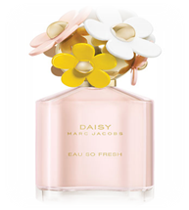  Daisy Marc Jacob, 75ml, RM 65.90 | 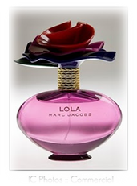  Lola Marc Jacob,100ml, RM 70.90 | 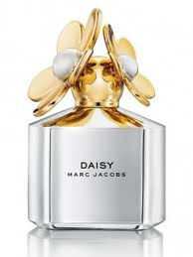  Daisy Silver Edition by Marc Jacobs, 100ml,RM 70.90 | 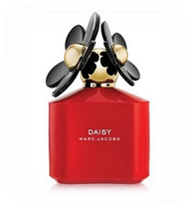  Daisy Marc Jacobs 100ml, RM 70.90
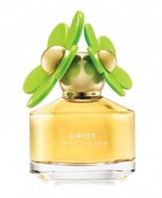  Daisy In Bloom Marc Jacobs, 100ml, RM 69.90 | 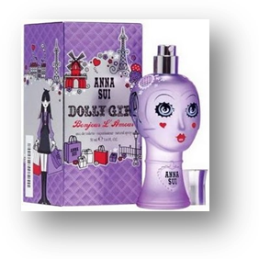  Anna Sui Dolly Girl Bonjour L' Amour,50ml (W), RM 59.90 | 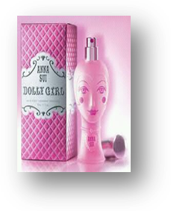  Anna Sui Dolly Girl,75ml (W),  RM 59.90 | 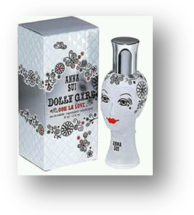  Ooh La Love by Anna Sui Dolly Girl,75ml (W),  RM 59.90
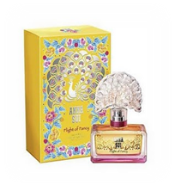  Flight of Fancy by Anna Sui for Women, 50ml,  RM 58.90 | 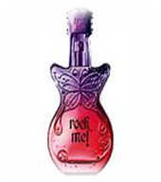  Rock Me by Anna Sui,100ml, RM 58.90 | 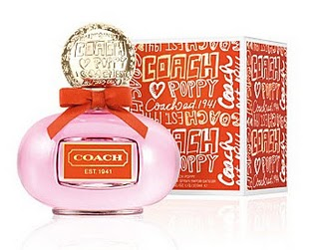  Poppy by Coach, 50ml for (W),RM 58.90 | 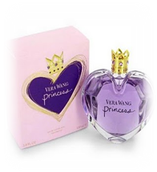  Vera Wang Princess for (W), 50ml,RM 58.90
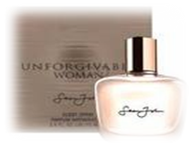  Unforgivable Woman by Sean John, 100ml,  RM 58.90 | 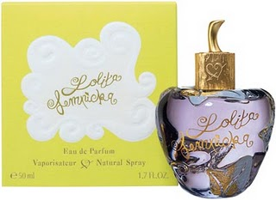  Lolita Lempicka by Lolita Lempicka,100ml,  RM 58.90 | 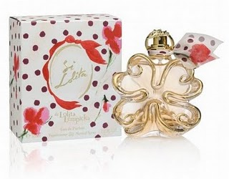  Si Lolita by Lolita Lempicka,100ml,  RM 59.90 | 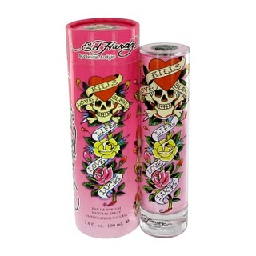  Ed hardy 100ml, RM 64.90
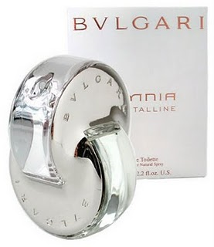  Bvlgari Omnia Crystalline, 65ml,RM64.90 | 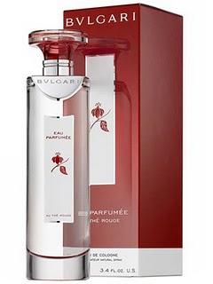  Bvlgari Eau Perfumee au The Rouge (Red Tea), 100ml, RM64.90 | 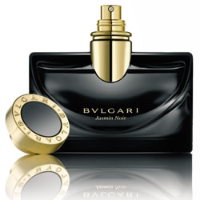  Bvlgari Jasmin Noir for Women, 100ml,RM64.90 | 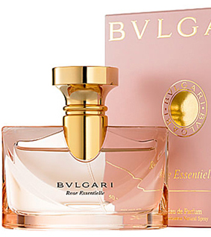  Bvlgari Rose Essentielle Perfume by Bvlgari for Women,100ml,RM64.90
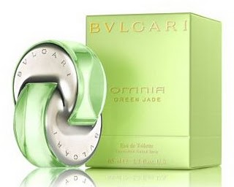  Omnia Green Jade,65ml,RM59.90 | 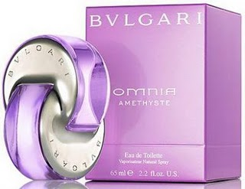  Omnia Améthyste by Bvlgari, 65ml, RM 59.90 | 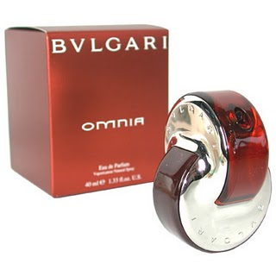  Bvlgari Omnia Eau De Parfume Spray 65Ml, RM 59.90 | 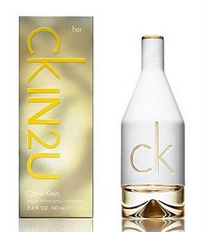  CKIn2U for Women, 125ml, RM 69.90
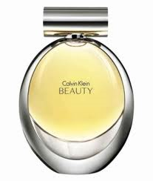  Beauty by Calvin Klein, 100ml,RM64.90 | 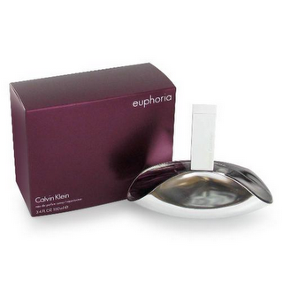  CK Euphoria for Women  100ml, RM64.90 | 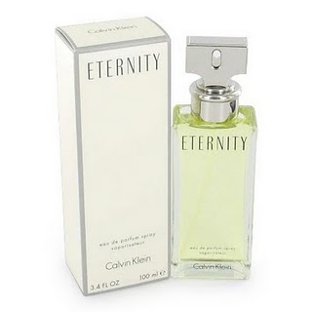  Eternity by Calvin Klein, 100ml,  RM64.90 | 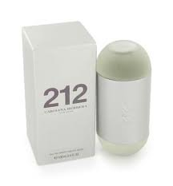  212 Lady by Carolina Herrera,100ml,RM 64.90
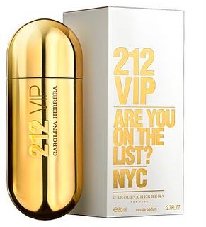  212 VIP by Carolina Herrera, 100ml, RM 64.90 | 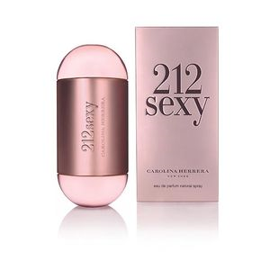  212 Sexy,100ml, RM 67.90 | 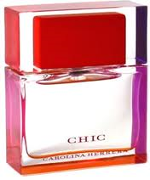  CHIC by Carolina Herrera for Women,100ml, RM 67.90 | 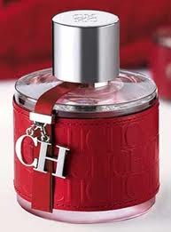  happy CH, 100ml (W),  RM 65.90
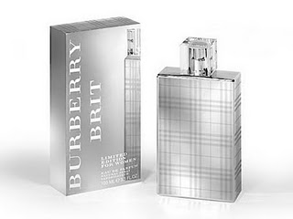  Burberry Brit Limited Edition For Women, 100ml, RM 67.90 | 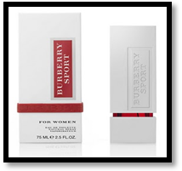  Burberry Sport for Women,75ml,RM 64.90 | 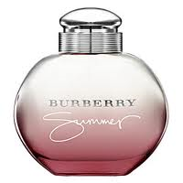  Summer for Women Burberry,100ml,  RM 67.90 | 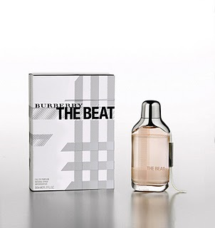  The Beat by Burberry for (W),100ml,RM 67.90
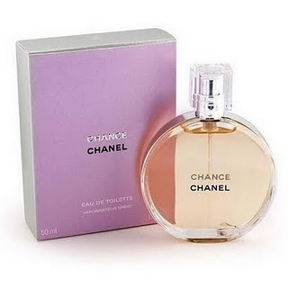  Chance Eau De Toilette by Chanel, 100ml, RM 64.90 | 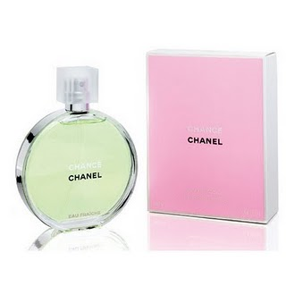  Chance Eau Fraiche by Chanel,100ml,RM 64.90 | 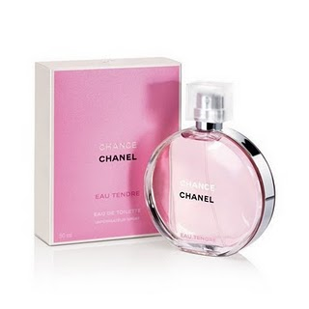  Chance Eau Tenfre by Chanel, 100ml, RM 64.90 | 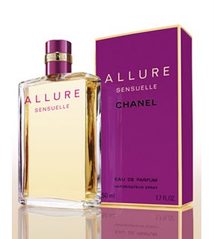  Allure Sensuelle, Chanel for Women,100ml,  RM 64.90
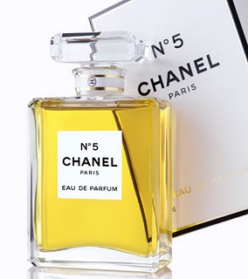  Chanel No 5 for Women,100ml,RM67.90 | 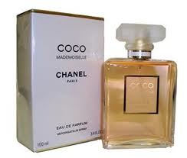  Coco Mademoiselle Perfume by Chanel,100ml (W),RM67.90 | 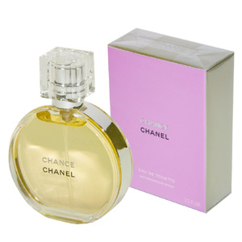  Chance by Chanel,100ml,RM 67.90 | 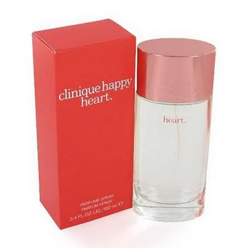  Clinique Happy Heart. For Women, 100ml,RM59.90
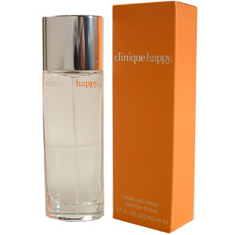  Happy Perfume by Clinique,100ml,RM59.90 | 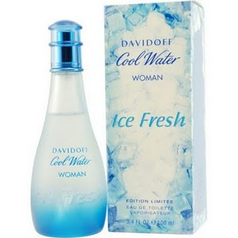  Ice Fresh Cool Water for Woman by Davidoff, 100ml,RM64.90 | 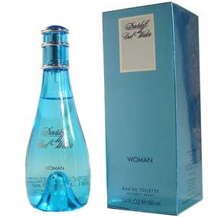  Cool Water by Davidoff for Women, 100ml,  RM 64.90 | 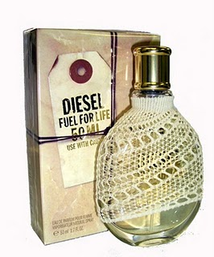  Fuel for Life by Diesel, for Women, 75ml, RM 64.90
  Amor Amor Tentation by Cacharel, for Women, 100ml,RM 59.90 | 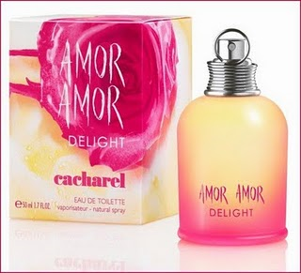  Amor Amor Delight by Cacharel, for Women, 100ml,RM 59.90 | 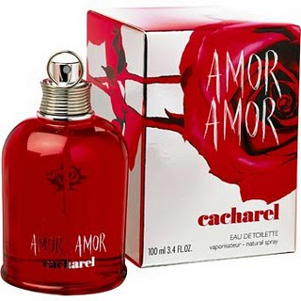  Amor Amor by Cacharel, for Women,100ml,  RM 59.90 | 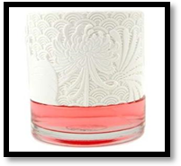  Scarlett by Cacharel for Women, 100ml,RM 56.90
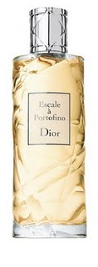  Escale a Portofino by Christian Dior, 100ml,  RM 67.90 | 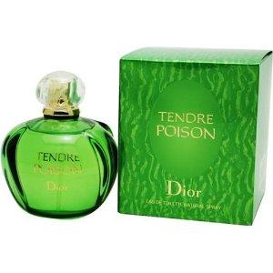  Tendre Poison by Dior 100ml,RM 67.90 | 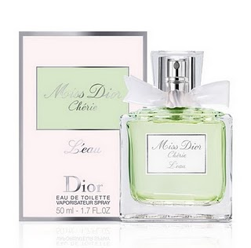  Miss Dior Cherie L’eau 50ml,RM 63.90 | 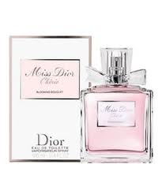  Miss Dior Cherie Blooming Bouquet 50ml,RM 63.90
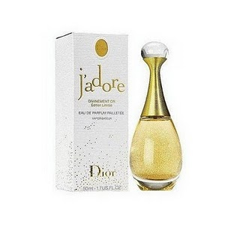  J Adore By Christian Dior 3.4 Oz 100ml, RM 69.90 | 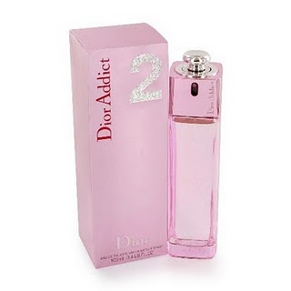  Christian DIOR Addict 2 100ml,RM 69.90 | 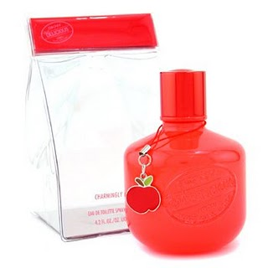  DKNY Red Be Delicious Charmingly, 125ml,RM 67.90 | 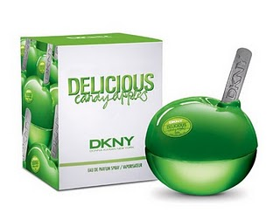  Candy Apple Sweet Caramel (Green),50ml for (W),RM 64.90
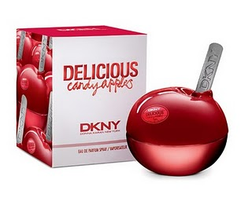Candy Apple Ripe Raspberry (Red), 50ml for (W),RM 62.90 | 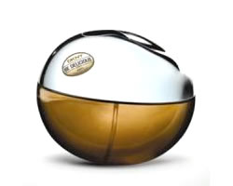  DKNY Be Delicious,100ml,  RM 67.90 | 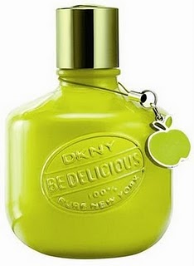DKNY Be Delicious Charmingly Delicious Limited Edition 125ml,RM 67.90 | 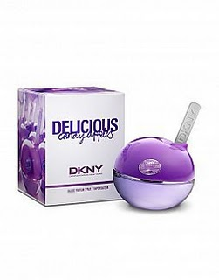DKNY Delicious Juicy Berry Candy Apple Fragrance 50ml,RM 64.90
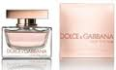  Rose the One by D & G, 100ml (W),RM 67.90 | 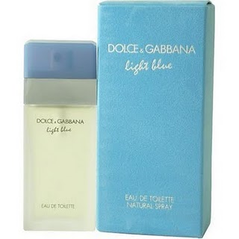  Light Blue Dolce & Gabbana for Women, 100ml,RM 64.90 | 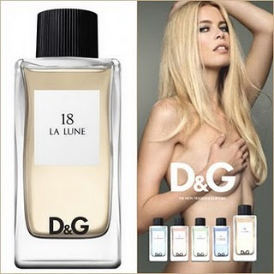  18 La Lune by Dolce & Gabbana ,100ml,RM64.90 | 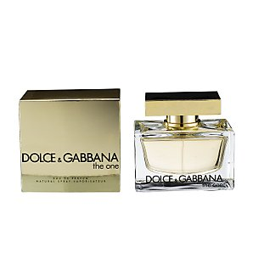  The One by Dolce & Gabbana for Women, 100ml,RM 64.90
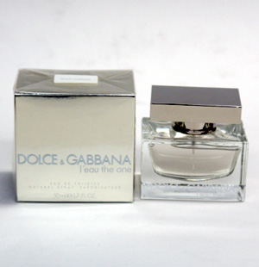  Dolce & Gabbana L'eau The One,100ml,RM 64.90 | 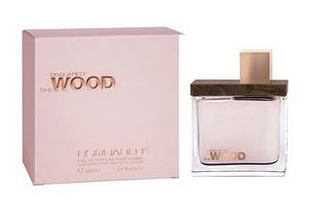  Wood by Dsquared for Women,100ml,RM 56.90 | 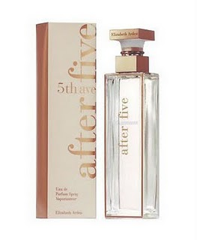  5th Avenue After Five,30ml,  RM 56.90 | 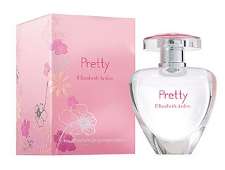  Pretty by Elizabeth Arden  100ml,RM 59.90
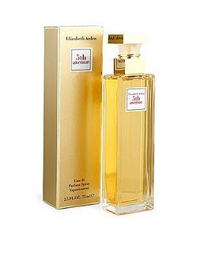  5th Avenue by Elizabeth Arden,30ml,RM 56.90 | 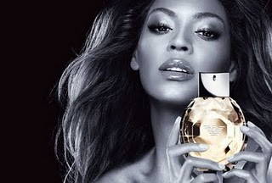  Diamonds Intense by Emporio Armani, 100ml for Woman,RM 67.90 | 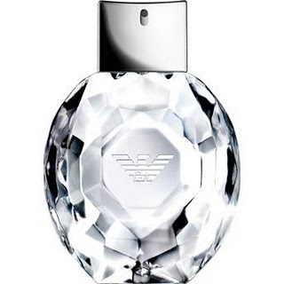  Diamonds by Emporio Armani, 100ml for Woman,RM 67.90 | 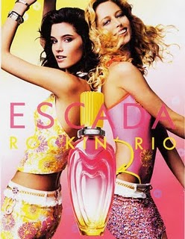  Rockin' Rio by Escada for Women, 100ml,RM 69.90
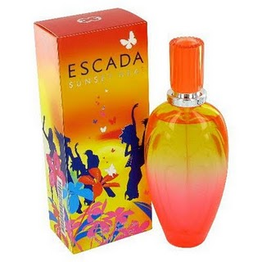  Sunset Heat by Escada for Women, 100ml,RM 69.90 | 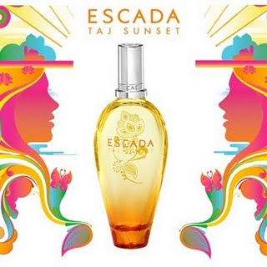  Taj Sunset by Escada, 100ml,RM 69.90 | 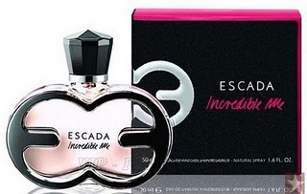  Incredible Me by Escada for Women,100ml,RM 69.90 | 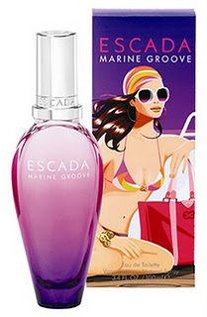  Marine Groove by Escada,women,100ml RM69.90
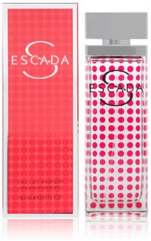  Escada S 90ml,RM 63.90 | 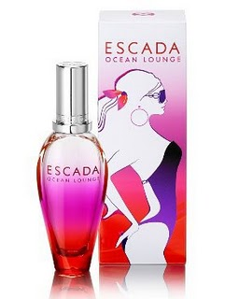  Escada Ocean Lounge Perfume,100 ml,RM 69.90 | 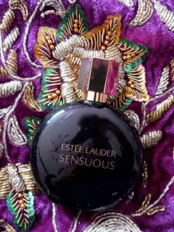  Estee Lauder Sensuous Noir, 100ml (W),  RM 63.90 | 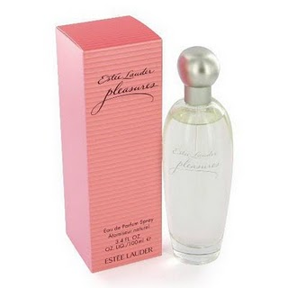  Estee Lauder Pleasure,50ml,RM 59.90
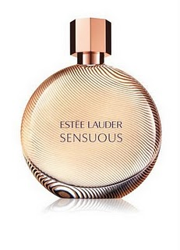  Estee Lauder Sensuous, 100ml (W),RM 64.90 | 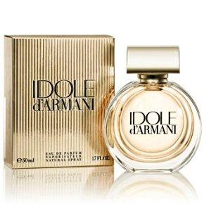  Idole d'Armani by Giorgio Armani for Women,100ml,RM64.90 | 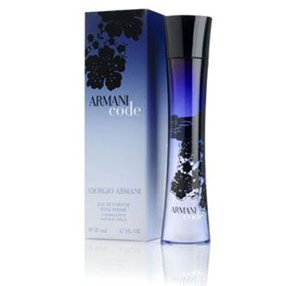  Armani Code for (W),75ml,RM 64.90 | 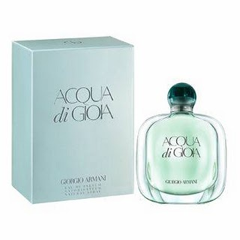  Acqua di Gioia by Giorgio Armani,100ml for (W),RM 65.90
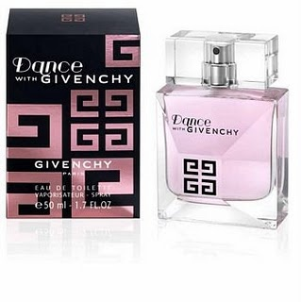  Dance by Givenchy for Women, 100ml,RM 59.90 | 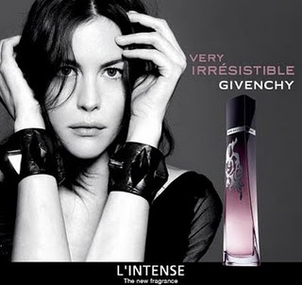  Givenchy Very Irresistible L'Intense  100ml,RM 64.90 | 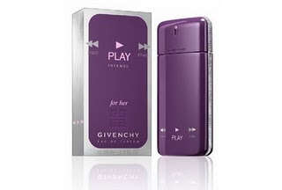  Givenchy Play Intense for Her,100ml,  RM 64.90 | 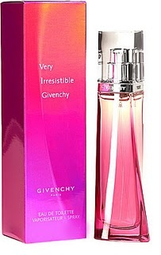  Very Irresistible by Givenchy for Women,100ml,RM 64.90
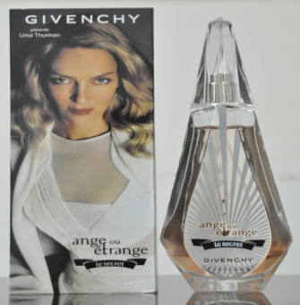  Givenchy Ange Ou Etrange Le Secret for Women,100ml,RM64.90 | 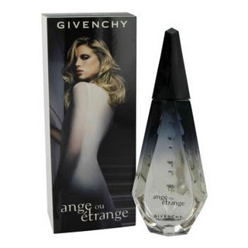  Ange Ou Etrange by Givenchy,100ml,  RM 64.90 | 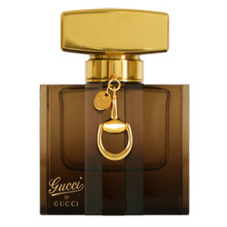  Gucci by Gucci,100ml,  RM67.90 | 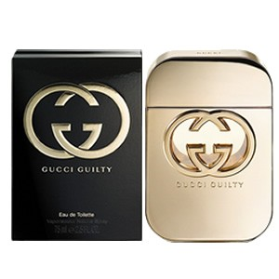  Gucci Guilty for Women - 100ml,RM 67.90
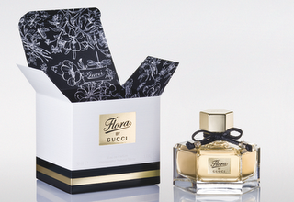  Flora by Gucci (Gold Cap) for Women, 75ml,  RM 64.90 | 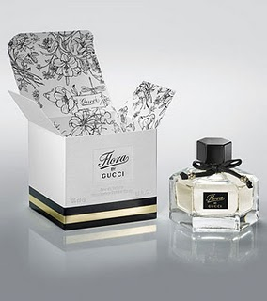  Flora by Gucci (Black Cap) for Women, 75ml,RM 64.90 | 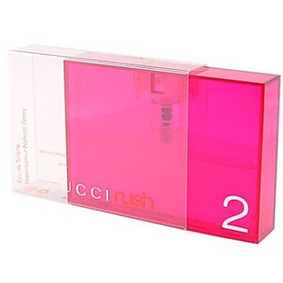  Gucci Rush 2 for Women,100ml,  RM 67.90 | 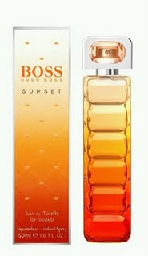  Hugo Boss Orange Sunset for Women. 100ml,  RM 67.90
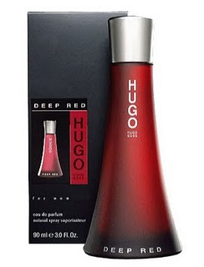  Hugo Red Deep by Hugo Boss ,90ml,RM66.90 | 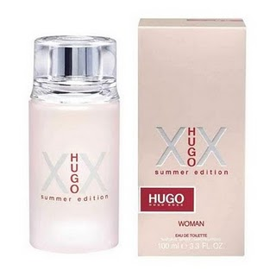  Hugo XX Summer Edition,100ml,RM66.90  100ml | 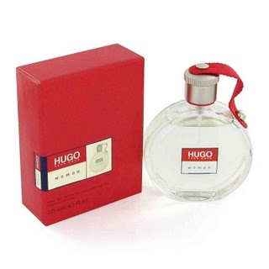  Hugo by Hugo for Women,100ml,  RM 67.90 | 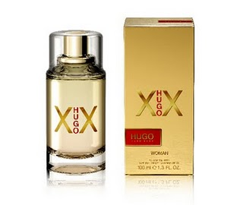  Hugo XX for Women  100ml,RM 67.90
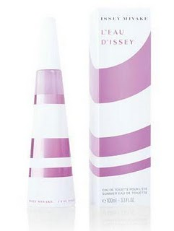  Issey Miyake Summer Edition 2 for Women,100ml,RM68.90  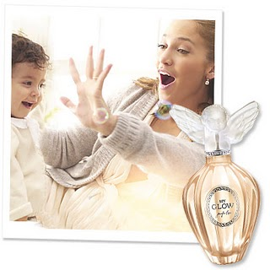  My Glow by Jennifer Lopez,100ml,RM 69.90 | 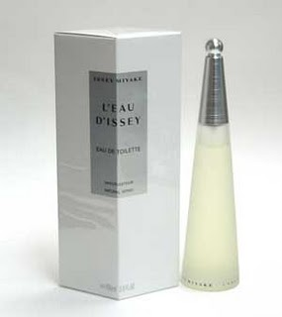  L'eau D'issey Issey Miyake,100ml,RM68.90  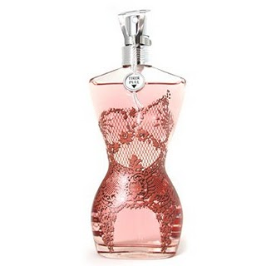  Le Classique by Jean Paul Gaultier, 100ml,RM65.90 | 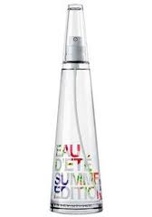L’EAU D’ISSEY Summer Fragrance 100ml,RM67.90  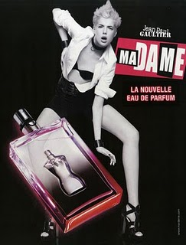  Jean Paul Gaultier Madame, La Nouvelle 100ml,RM 65.90 | 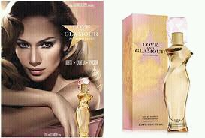  Love & Glamour by Jennifer Lopez,100ml,  RM 69.90    Jean Paul Gaultier Madame, 100ml RM 65.90
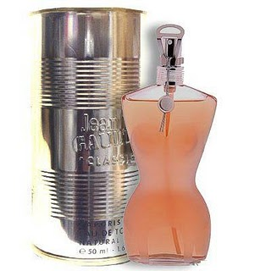  Jean Paul Gaultier for Women,100ml,RM65.90 | 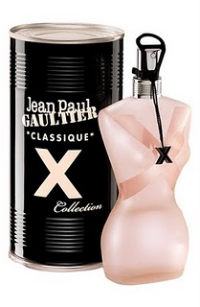  Jean Paul Gaultier, Classique X Collection ,100ml,RM65.90 | 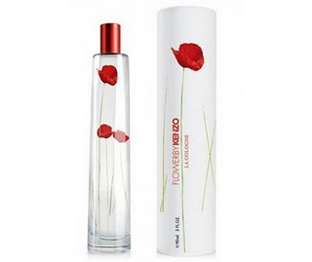  Flower by Kenzo,90ml,  RM59.90 | 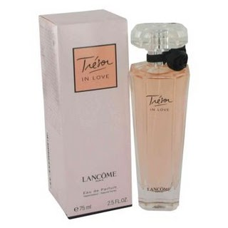  Tresor in Love by Lancome for Women, 75ml,RM59.90
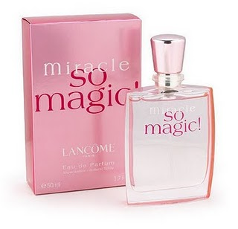  Miracle So Magic by Lancome for Women,100ml,RM66.90 | 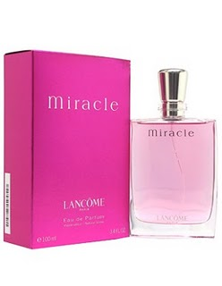  MiraclebyLancome,100ml,  RM66.90 | 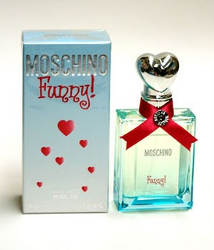  Funny by Moschino, 100ml,RM65.90 | 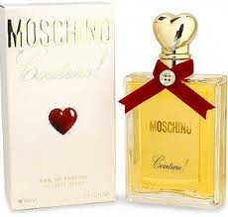  Couture by Moschino for Women, 100ml,RM65.90
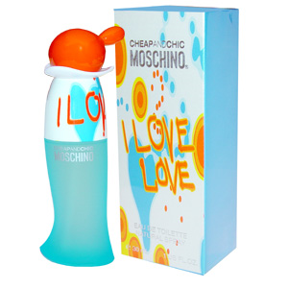  Cheap & Chic I Love Love by Moschino for Women, 100ml,RM 66.90 | 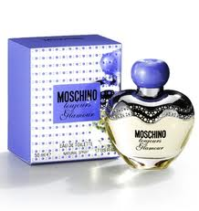  Moschino Toujours Glamour by Moschino,100ml,  RM 66.90 | 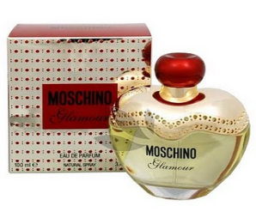  Moschino Glamour,100ml,  RM66.90 | 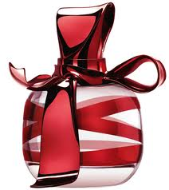  Ricci Ricci Dancing Ribbon by Nina Ricci,100ml,RM69.90
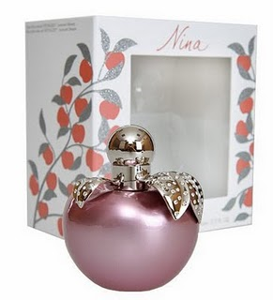  Nina Ricci Precious Swarovski Edition,80ml,RM67.90 | 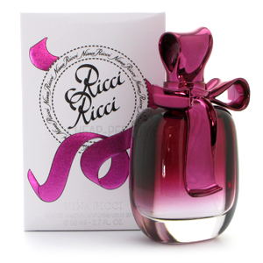  Ricci Ricci by Nina Ricci, ,80ml,RM67.90 | 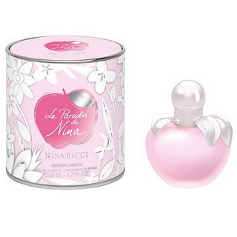  Nina Ricci Le Paradis de Nina, for Women, 5oml,RM 59.90 | 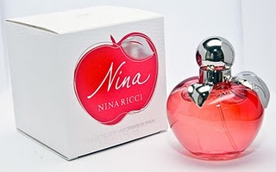  Nina by Nina Ricci, 100ml,RM65.90
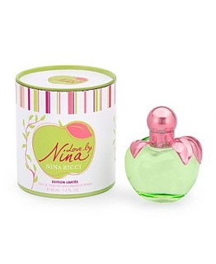  Love By Nina,50ml,RM59.90 | 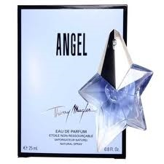  Angel by Thierry Mugler, 100ml (W),RM59.90 | 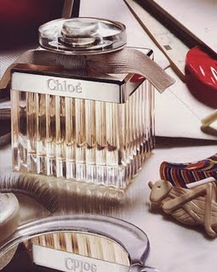  Chloe for Women, 75ml,RM59.90 | 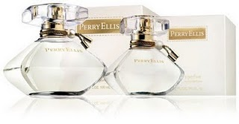  Perry Ellis, 100ml for Women,RM63.90
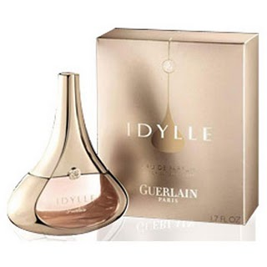  Idylle by Guerlain for Women,RM63.90 | 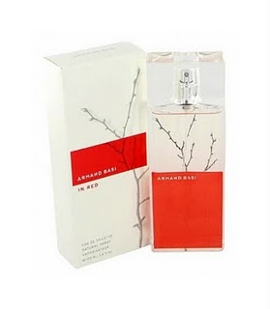  Armand Basi in Red for Women,100ml,RM56.90 | 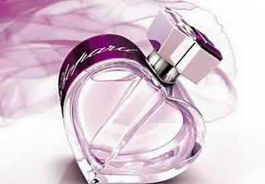  Chopard Happy Spirit ,100ml,RM59.90 | 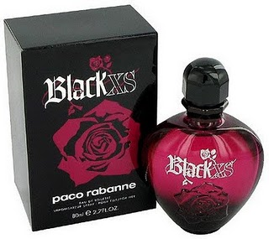  Black XS by Paco Rabanne , 80ml,RM 63.90
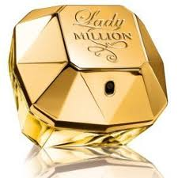Lady Million Perfume by Paco Rabanne,100ml,RM69.90 | 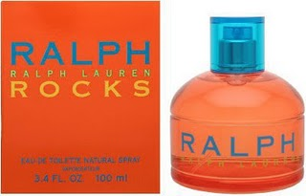  Ralph Rock, 100ml,RM69.90 | 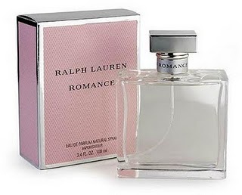  Ralph Lauren Romance,100ml,  RM69.90 | 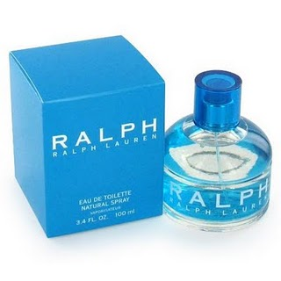  Ralph by Ralph Lauren, for Women 100ml RM69.90
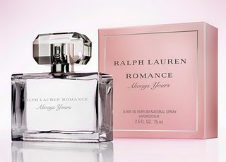  Romance by Ralph Lauren 100ml  RM69.90 | 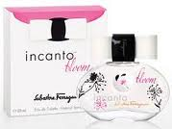  Incanto Bloom by Salvatore Ferragamo, 100ml (W),RM67.90 | 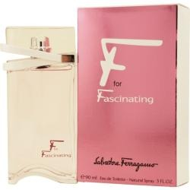  F for Fascinating by Salvatore Ferragamo , 100ml,RM67.90 | 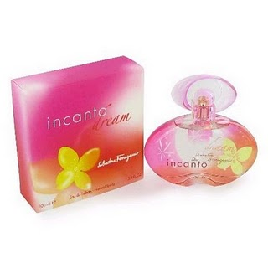  Incanto Dream by Salvatore Ferragamo 100ml,RM67.90
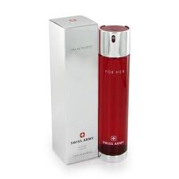  Swiss Army for Her,50ml,RM59.90 | 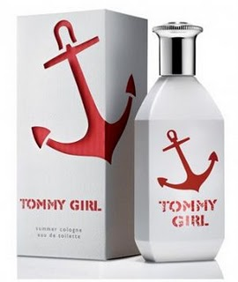  Tommy Girl Summer 2010, 100ml,RM66.90 | 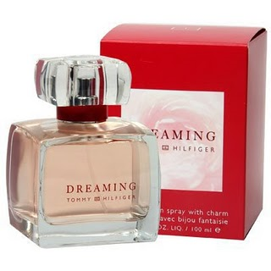  Dreaming by Tommy Hilfiger 100ml,RM66.90 | 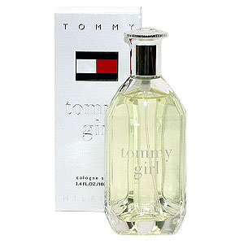  Tommy Girl by Tommy Hilfiger,100ml,RM66.90
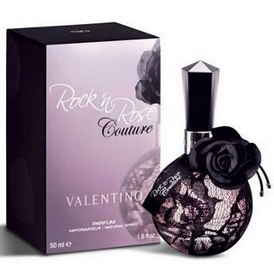  Rock & Rose Couture for Women, 90ml,RM64.90 | 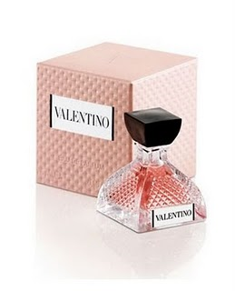  Valentino by Valentino, 90ml,RM64.90 | 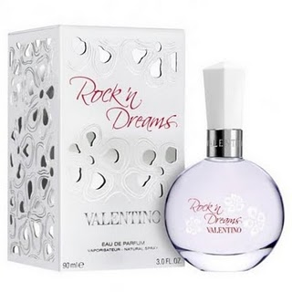  Rock & Dreams by Valentino, 90ml,RM64.90 | 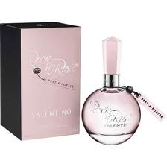  Rock & Rose Pret A Porter by Valentino,90ml,RM64.90
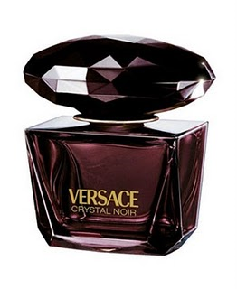  Versace Crystal Noir,90ml,RM67.90 | 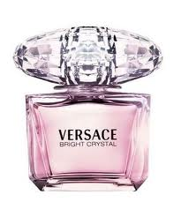  Versace Bright Crystal,90ml,RM67.90 | 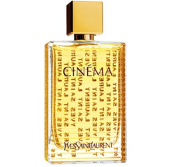  Cinema by YSL, for Women 100ml,RM65.90 | 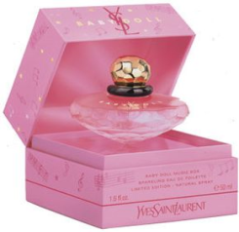  Baby Doll Music Box by YSL, 50ml,RM62.90
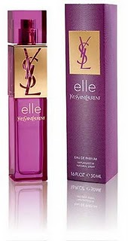  Elle by YSL for Women,50ml,RM64.90 | 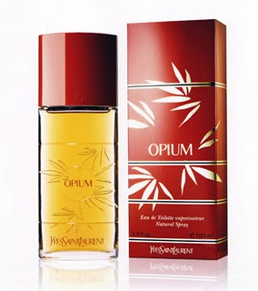  Opium by YSL for Women,100ml,RM64.90 | 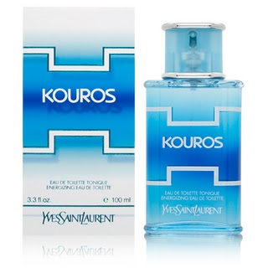  Kouros Energizing by YSL 100ml,RM59.90

